Question 1: (3.0 Point)
Design the form might look something like figure below, named the java file is AOutcome.java (0.5 Point)
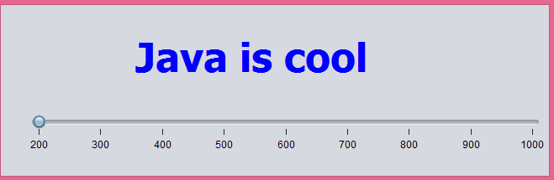
The frame including a label value is “Java is cool” and a jslider (min value = 200, max value = 1000, minor tick = major tick = 100).
At the running time, the color of lable changes between red and blue color after every 200 milisecond (0.5 point). When user slide the slider, the interval of changing color of label is updated and is equals to value of jslider (in miliseconds) (2.0 Point).

